**NUTRITION ASSISTANT APPLICATION**

**TEAM ID :** PNT2022TMID13264

**TEAM LEADER :**

K.GURU KEERTHIKA

**TEAM MEMBERS :**

1) A. APOORVA

1. K. DHANALAKSHMI

3) P. MALATHI

|  |  |  |
| --- | --- | --- |
| **CHAPTER NO** | **CHAPTER** | **PAGE NO** |
| **1** | **INTRODUCTION** | **1** |
|  | 1.1 PROJECT OVERVIEW | 1 |
|  | 1.2 PURPOSE | 3 |
| **2** | **LITERATURE SURVEY** | **6** |
|  | 2.1 EXISTING PROBLEM | 8 |
|  | 2.2 REFERNCES | 8 |
|  | 2.3 PROBLEM STATEMENT DEFINITION | 9 |
| **3** | **IDEATION AND PROPOSED SYSTEM** | **11** |
|  | 3.1 EMPATHY MAP CANVAS | 11 |
|  | 3.2 IDEATION AND BRAIN STROMING | 11 |
|  | 3.3 PROPOSED SOLUTION | 12 |
|  | 3.4 PROBLEM SOLUTION FIT | 13 |
| **4** | **REQUIREMENT ANALYSIS** | **14** |
|  | 4.1 FUNTIONAL REQUIREMENT | 14 |
|  | 4.2 NON FUNTIONAL REQUIREMENT | 14 |
| **5** | **PROJECT DESIGN** | **15** |
|  | 5.1 DATA FLOW DIAGRAM | 15 |
|  | 5.2 SOLUTION AND TECHNICAL ARCHITECTURE | 16 |
|  | 5.3 USER STORIES | 16 |
| **6** | **PROJECT PLANNING AND SCHEDULING** | **17** |
|  | 6.1 SPRINT PLANNING AND ESTIMATION | 17 |
|  | 6.2 SPRINT DELIVERY SCHEDULE | 17 |
| **7** | **CODING AND SOLUTIONING** | **18** |
|  | 7.1 FEATURES | 18 |
| **8** | **RESULT** | **20** |
|  | 8.1 PERFORMANCE MATRIX | 20 |
| **9** | **ADVANTAGES AND DISADVANTAGES** | **22** |
|  | 9.1 DISADVANTAGES | 22 |
|  | 9.2 ADVANTAGES | 22 |
| **10** | **CONCLUSION** | **23** |
| **11** | **FUTURE SCOPE** | **24** |
| **12** | **APPENDIX** | **25** |
|  | 12.1 SOURCE CODE | 25 |
|  | 12.2 DEMO LINK | 29 |

**1. INTRODUCTION**

* 1. **PROJECT OVERVIEW**

1. **BACKGROUND**

The Nutrition Results Package is a ten-year program framework authorized in 1998. Under this authorization, The Food and Nutrition Technical Assistance (FANTA) project was awarded competitively in September 1998 to the Academy for Educational Development (AED) as the prime contractor, with Cornell University and Tufts University as subcontractors. The FANTA proposal included a memorandum of understanding with Food Aid Management (FAM)1, a consortium of Private Voluntary Organizations (PVOs), referred to as Cooperating Sponsors (CS), implementing Title II food aid development and emergency programs.

The overall purpose of FANTA is "improved food and nutrition policy, strategy, and program development". Three Intermediate Results (IRs) were identified to achieve this purpose: IR.

1. USAID's and Cooperating Sponsors' nutrition and food security-related program development, analysis, monitoring, and evaluation improved, IR.

2. USAID, host country governments, and Cooperating Sponsors establish improved, integrated nutrition and food security-related strategies and policies, and IR.

3. Best practices and acceptable standards in nutrition and food security-related policy and programming adopted by USAID, Cooperating Sponsors, and other key stakeholders.

The Cooperative Agreement states that the central activity of FANTA is to provide technical assistance to USAID, Title II PVOs, and host governments in planning and implementing cost-effective programs that can bring about measurable changes in the nutritional status of target populations. FANTA is unique in that it is charged with taking a broad approach to food security by assisting Missions and partners to examine how non-nutrition programs can be used to improve nutrition and to help ensure that investments in nutrition are focused on the best possible mix of interventions to achieve food security.

The FANTA mandate is threefold:

* To provide technical assistance to programs,
* To lead or contribute to policy discussions, and
* To identify and document promising practices and sponsor their

dissemination.

1. Food Aid Management is a consortium of a number of private voluntary organizations that collaborate on technical and administrative issues related to food aid programming
2. The terms private voluntary organization (PVO) and cooperating sponsor are used interchangeably in this report.

Technical assistance includes face-to-face meetings with program officials and staff to identify and solve problems; written materials such as technical updates, state-of-the-art guides on programming, and summaries of lessons learned; and formal reviews of Title II program proposals, implementation plans, program evaluations, and training activities.

The primary partners in FANTA include the following:

* Fifteen PVOs that design and implement more than 80 Title II development (non- emergency) programs in 27 countries. PVOs carry out interventions across many sectors, particularly agriculture; natural resources; microfinance; education; water and sanitation; health; nutrition; and information, education, communications, and behavior change activities.
* Global Bureau/Office of Population, Health and Nutrition (G/PHN), particularly for maternal health, child health, and HIV/AIDS teams and projects.
* Bureau of Humanitarian Response (BHR) Food for Peace (FFP) Program.
* USAID Missions and PVOs in 4–6 priority countries.
* REDSO/ESA and Africa Bureau.
* Tufts University, Cornell University, International Food Policy and Research Institute (IFPRI), World Health Organization (WHO), and Freedom from Hunger (FFH).

1. **ASSESSMENT SCOPE OF WORK**

Annex A contains a detailed scope of work. The assessment is meant to address the following points:

* 1. Progress made to date in three intermediate results:
     + Programs.
     + Policies and strategies.
     + Best practices and acceptable standards.
  2. The appropriateness and effectiveness of approaches, strategies, and activities by FANTA in achieving results to date, including operations/management, resource use, staff, communications, and collaborations. Recommend changes, if any, needed to improve these areas in the remainder of the current agreement.
  3. Whether changes are needed to the FANTA project, objectives for the second

five-year agreement to ensure relevance to the current USAID policy and programming environment, and to ensure that it meets emerging and future needs.

This report is organized into four sections. The first is a review of the overall project operating environment and general findings and recommendations, followed by three sections that examine the three intermediate results. Each section contains a purpose, objectives, and expected results; a review of approaches and operations in project years 1–3; a summary of technical assistance and findings of the assessment team; and recommendations for the remainder of the current agreement and for the second five-year period.

**C. METHODOLOGY**

The team first conducted a complete review of FANTA publications and documents

(Annex B). The team then held meetings with key USAID/Washington program managers and senior staff, a majority of the FANTA project staff, and several PVO representatives whose offices are based in the Washington, DC area. The team also conducted telephone interviews with USAID Mission staff in priority countries, key subcontractors, and United Nations agency staff (Annex C). A list of interview questions (Annex D) was provided to the team by the FANTA Cognizant Technical Officer (CTO) for general guidance.

The interviews were open-ended and usually took one hour. Most meetings were conducted by two or three members of the team, whereas telephone interviews were usually conducted by one team member who was assigned to that area. A total of 44 people were interviewed in person or by telephone (Table 1). FANTA staff were also interviewed (not shown in Table).

**NUMBER OF PEOPLE INTERVIEWED FOR FANTA ASSESSMENT BY ORGANIZATION**

|  |  |  |  |
| --- | --- | --- | --- |
| **USAID/W**  Global Health 7  DCHA 7  PPC 3  Africa Bureau 1  LAC Bureau 1  EGAT 1 | **USAID Missions**  REDSO/ESA 2  Ethiopia 1  Haiti 1  Honduras 2  India 1  Madagascar 1 | **Subcontractors**  Cornell 2  Tufts 2  IFPRI 2  **UN Agencies**  UNICEF 1  WFP 1 | **Title II PVOs and others**  Africare 1  CARE 2  Save the Children 1 World Vision 2  CRS 1  FAM 1 |

The person contacted was formerly with G/PHN.

CRS is Catholic Relief Services; FAM, Food Aid Management; LAC, Latin America and the Caribbean; UNICEF, United Nations Children’s Fund; WFP, World Food Programme.

* 1. **PURPOSE**

1. **OPERATING ENVIRONMENT**

Title II food aid programs represent approximately one third of the annual USAID budget and are therefore an important resource and platform for reaching undernourished women and children throughout the developing world. The 1998 request for applications stated:

“The Program (FANTA) affords G/PHN an unprecedented opportunity to influence the quality and health impact of food aid programming, both through its role in providing direct assistance to Cooperating Sponsors, Missions and BHR/FFP, and through its role in facilitating technical exchange and cooperation with other ongoing G/PHN programs.”

FANTA was envisioned to serve as a link between BHR/FFP and G/PHN through its activities in health and nutrition programming among Title II PVOs, and by integrating those activities within the food security strategies and population, health, and nutrition portfolios of 4–6 priority countries. Through this link, FANTA was to have compiled lessons and good field practices in order to guide the USAID food security and nutrition program strategy. Within G/PHN, FANTA was also seen as serving as a link among the divisions of maternal health, child survival, and HIV/AIDS.

Whether FANTA was achieving its goal would be measured by assessing the percentage of programs in priority countries that report better nutrition among beneficiaries in a given year. Nine monitoring indicators have been defined for tracking how well the three intermediate results are achieved .

As a technical assistance project, FANTA results are primarily achieved through its partners and stakeholders. People interviewed by the team readily acknowledged that FANTA has operated within several constraints in trying to affect policies and programs, and to build linkages between the various stakeholders. These constraints include the following:

* + A general lack of knowledge and experience of Title II programs within G/PHN and country Missions.
  + Minimal internal demand for broad-based nutrition work within G/PHN, and a lack of consensus within USAID/Global Health about nutrition strategy.
  + The relatively limited base of global knowledge of nutrition program successes. This is particularly true for emerging areas of interest such as women’s nutrition, nutritional support and care for persons living with HIV/AIDS.
  + Title II PVOs (i.e., Cooperating Sponsors) are independent organizations and collaboration with FANTA on specific activities is a joint decision.

These constraints have to some degree affected the approaches and activities by FANTA in all three intermediate results and the results achieved in each area. It has been widely acknowledged that prompting major change in the face of the constraints listed above is outside the manageable scope of FANTA.

On the positive side, there is renewed interest and commitment from G/PHN leaders in bringing nutrition more fully into the G/PHN portfolio. “This may be nutrition’s moment,” said the office director. FANTA, as the only multi-sectoral nutrition project within USAID, is in an ideal position to make the most of this opportunity.

**B. FUNDING AND EXPENDITURES TO DATE**

The original funding ceiling for the cooperative agreement was $30 million; up to $10 million was to have come from G/PHN core funds and $20 million from field support or add-on funding over the initial five-year period. Four years into the five-year agreement, as of September 30, 2001, the FANTA project has received a total of $12,007,112 in authorized funding. This represents 40 percent of the original funding level. Slightly more than half the funds are from the G/PHN core budget ($6.4 million) and the remaining ($5.9 million) are field support funds from USAID bureaus (BHR, Africa, PPC), REDSO/ESA, and seven countries.3

Table 2 shows that only half (53 percent) of the $12 million obligated funds have been spent. Field support and core funds constitute 42 percent and 53 percent, respectively, of obligated funds.

**FANTA authorized funding and expenditures as of September 30, 2001**

|  |  |  |
| --- | --- | --- |
| **Funding source** | **Obligated (as of 9/30/01)** | **Expended (% of obligated)** |
| G/PHN | $6,420,147 | $3,355,243 (53%) |
| BHR | $3,069,000 | $1,968,704 (31%) |
| Field support | $2,517,965 | $1,066,026 (42%) |
| Subtotals | $12,007,112 | $6,389,974 (53%) |

According to the CTO, overall underspending is in the range of 10–15 percent. FANTA is expected to maintain a 13–15 month pipeline of project funds (approximately $1.2–1.5 million) at the beginning of the fiscal year due to delays in annual obligations. In addition, some vacancies within the FANTA project staff have not been filled in the last three years. FANTA staff has a mix of background, skills, and experience to reflect the multi-sectoral food security approach of nutrition, agriculture, food consumption, economics, emergencies, and public health. The current staff consists of the project director, 11 technical specialists (one of whom also serves as the deputy director), and three program associates/assistants. The core staff is supplemented with short-term consultants and one long-term advisor based in Nicaragua. The overall purpose of the IR.1 is to improve food security and nutrition programming by supporting USAID/BHR/FFP and its Cooperating Sponsors. The aim of the intermediate result is to strengthen the capacity of stakeholders who analyze food and nutrition security problems, and who design projects and report their progress. Food aid programs are important because they provide nutrition directly to people, and because food aid programs are designed to complement other health and nutrition activities.

**2. LITERATURE SURVEY**

1) Bickel, G., M. Andrews, and B. Klein 1996. Measuring food security in the United States: A supplement to the CPS. In Nutrition and Food Security in the Food Stamp Program. Washington, D.C.: U.S. Department of Agriculture. at el.,

Although most households in the United States are food secure, during the period 1996-98 some 10 million U.S. households (9.7 percent of total) were food insecure--that is, they did not always have access to enough food to meet basic needs. Included among these were 3.5 percent of households in which food insecurity was severe enough that one or more household members were hungry at least some time during the year due to inadequate resources for food. The prevalence of food insecurity and hunger varied considerably among States. Eleven States, located in an arc along the western and southern borders of the country, and the District of Columbia, had rates of food insecurity significantly above the national average. By contrast, 20 States--most of them in the Midwest, Great Lakes, and Northeast--had rates of food insecurity significantly below the national average. High-food-insecurity States generally had higher than average poverty rates and higher than average use of food stamps, but there were some notable exceptions.

1. Brady, H.E., and B.W. Snow 1996. Data Systems and Statistical Requirements for the Personal Responsibility and Work Opportunity Reconciliation Act of 1996. Paper presented to the Committee on National Statistics, National Research Council, Washington, D.C., October 25, 1996. at el.,

Bill Clinton advocated for welfare reform during his 1992 campaign, but it was the Republicans who actively pushed the reform forwards after they won a majority in Congress in the 1994 congressional elections.On the Republican side, the 1994 "Contract with America" provided the groundwork to pursue welfare reform. It was a policy proposal collection intended to convince voters during the congressional elections and proposed a stricter method of cutting social welfare. Its proposals found favour with many of their fellow members of congress, who drafted their own legislation without the involvement of the White House. The legislation pushed for a strong connection between benefits payments and employment. It was "based on a simple compact designed to reinforce and reward work. Each recipient will be required to develop a personal employability plan designed to move that individual into the workforce as quickly as possible.”

1. Carlson, S. 1996. Nutrition Assistance and Welfare Reform: Understanding the Consequences of Change. Unpublished paper presented at the Conference on National Statistics on Health and Social Welfare Programs, Committee on National Statistics, National Research Council, Washington, D.C., December 12, 1996. at el.,

We assessed the relation between the work promotion, welfare reduction, and marriage goals of welfare reform and the stability of health insurance of parents in transition from welfare to work.We analyzed a panel survey (1999–2002) of a stratified random sample of Illinois families receiving welfare in 1998 (n=1363).Medicaid remains the foremost source of health insurance despite a significant decline in the proportion of parents with Medicaid. Regardless of work/welfare status in year 1, transitioning to work only or no work/no welfare increased the likelihood of having unstable health insurance in years 2 and 3 compared with those who remained on welfare only.Parents who meet the welfare reform goals of work promotion and reduction of welfare dependence experience significant loss and instability of health insurance.

1. Center for Budget and Policy Priorities 1996. The New Welfare Law-Summary. D.A. Super, editor; , S. Parrott, editor; , S. Steinmetz, editor; , and C. Mann, editor. . at el.,

A booming economy contributed far more than welfare reform to the gains in single mothers’ employment in the 1990s, and many of those gains have since disappeared**.**A highly regarded [study](http://www.mitpressjournals.org/doi/abs/10.1162/003465303765299891) by University of Chicago economist Jeffrey Grogger found that welfare reform accounted for just 13 percent of the rise in employment among single mothers in the 1990s.  The Earned Income Tax Credit (which policymakers expanded in 1990 and 1993) and the strong economy were bigger factors, accounting for 34 percent and 21 percent of the increase, respectively.While the booming economy helped many families move from welfare to work during the 1990s, the labor market situation is much weaker today.  The share of single mothers without a high school degree with earnings rose from 49 percent to 64 percent between 1995 and 2000 but has since fallen or remained constant almost every year since then.  At 55 percent, it’s now just slightly above its level in 1997, the first full year of welfare reform (see first graph).

1. Cook, J., L. Sherman, and L. Brown 1995. Impact of Food Stamps on the Dietary Adequacy of Poor Children . Boston, MA: Tufts University School of Nutrition, Center on Hunger, Poverty, and Nutrition Policy. at el.,

The Food Stamp Program (FSP) is the nation's primary nutrition assistance program for poor families in the United States. This study compared the dietary adequacy of children in poor families receiving food stamps to that of children in poor families not receiving such assistance. Data used were obtained from the 1986 United States Department of Agriculture Continuing Survey of Food Intakes by Individuals, a nationally representative sample survey consisting of an overall sample from all households in the 48 contiguous states, and a low-income sample emphasizing households with incomes below 125 percent of the federal poverty thresholds. This analysis focuses on the low-income sample. The findings indicated that compared to nonparticipating poor children ages 1 to 5, the dietary intake of children whose households received food stamps was significantly better in 10 of 16 major nutrients analyzed. The findings indicate that the Food Stamp Program is highly effective in improving the nutritional status of children in poor families.

6) Devaney, B.L., M.R. Ellwood, and J.M. Love 1997. Programs that mitigate the effects of poverty on children. The Future of Children 7(2):88-112. at el.,

This article reviews six federally funded in-kind public assistance programs that are intended to mitigate the effects of poverty on low-income children by providing access to basic human necessities such as food, housing, education, and health care. The evidence suggests that, while each program can be improved, these programs do achieve their basic objectives. In general, food stamps, the Special Supplemental Food Program for Women, Infants, and Children (WIC), and school nutrition programs are successful at providing food assistance to low-income children, starting with the prenatal period and continuing through the school years. The Food Stamp Program provides food assistance nationwide to all households solely on the basis of financial need and is central to the food assistance safety net for low-income children. The WIC program has helped reduce the prevalence of iron-deficiency anemia in infants and children and has increased intakes of certain targeted nutrients for program participants. The school nutrition programs provide free or low-cost meals that satisfy the dietary goals of lunches and breakfasts to most school-age children. The Medicaid program has extended health insurance coverage to millions of low-income children.

**2.1 EXISTING PROBLEM**

Healthy nutrition contributes to preventing non-communicable and diet-related diseases. Recommender systems, as an integral part of mHealth technologies, address this task by supporting users with healthy food recommendations. However, knowledge about the effects of the long-term provision of health-aware recommendations in real-life situations is limited. This study investigates the impact of a mobile, personalized recommender system named Nutrilize. Our system offers automated personalized visual feedback and recommendations based on individual dietary behaviour, phenotype, and preferences. By using quantitative and qualitative measures of 34 participants during a study of 2–3 months, we provide a deeper understanding of how our nutrition application affects the users’ physique, nutrition behaviour, system interactions and system perception. Our results show that Nutrilize positively affects nutritional behaviour (conditional R2=.342R2=.342) measured by the optimal intake of each nutrient. The analysis of different application features shows that reflective visual feedback has a more substantial impact on healthy behaviour than the recommender (conditional R2=.354R2=.354). We further identify system limitations influencing this result, such as a lack of diversity, mistrust in healthiness and personalization, real-life contexts, and personal user characteristics with a qualitative analysis of semi-structured in-depth interviews. Finally, we discuss general knowledge acquired on the design of personalized mobile nutrition recommendations by identifying important factors, such as the users’ acceptance of the recommender’s taste, health, and personalization.

**2.2 REFERENCES**

1. Bickel, G., M. Andrews, and B. Klein 1996. Measuring food security in the United States: A supplement to the CPS. In Nutrition and Food Security in the Food Stamp Program. Washington, D.C.: U.S. Department of Agriculture.
2. Brady, H.E., and B.W. Snow 1996. Data Systems and Statistical Requirements for the Personal Responsibility and Work Opportunity Reconciliation Act of 1996. Paper presented to the Committee on National Statistics, National Research Council, Washington, D.C., October 25, 1996. Available online at [http://ucdata​.berkeley​.edu/pubs/NAS1196.html](http://ucdata.berkeley.edu/pubs/NAS1196.html).
3. Carlson, S. 1996. Nutrition Assistance and Welfare Reform: Understanding the Consequences of Change. Unpublished paper presented at the Conference on National Statistics on Health and Social Welfare Programs, Committee on National Statistics, National Research Council, Washington, D.C., December 12, 1996.
4. Center for Budget and Policy Priorities 1996. The New Welfare Law-Summary. D.A. Super, editor; , S. Parrott, editor; , S. Steinmetz, editor; , and C. Mann, editor. . Internet URL [http://www​.cbpp.org/WCNSUM.HTM](http://www.cbpp.org/WCNSUM.HTM).
5. Cook, J., L. Sherman, and L. Brown 1995. Impact of Food Stamps on the Dietary Adequacy of Poor Children . Boston, MA: Tufts University School of Nutrition, Center on Hunger, Poverty, and Nutrition Policy.
6. Devaney, B.L., M.R. Ellwood, and J.M. Love 1997. Programs that mitigate the effects of poverty on children. The Future of Children 7(2):88-112.

**2.3 PROBLEM STATEMENT DEFINITION**

Due to the ignorance of healthy food habits, obesity rates are increasing at an alarming speed, and this is reflective of the risks to people’s health. People need to control their daily calorie intake by eating healthier foods, which is the most basic method to avoid obesity. However, although food packaging comes with nutrition (and calorie) labels, it’s still not very convenient for people to refer to App-based nutrient dashboard systems which can analyses real-time images of a meal and analyses it for nutritional content which can be very handy and improves the dietary habits, and therefore, helps in maintaining a healthy lifestyle. The main objective of this project is to building a web App that automatically estimates food attributes such as ingredients and nutritional value by classifying the input image of food.

|  |  |  |  |  |  |
| --- | --- | --- | --- | --- | --- |
| **Problem Statement (PS)** | **I am (Customer)** | **I am trying to** | **But** | **Because** | **Which makes me feel** |
| PS-1 | Fitness freak | Finding a perfect pre workout plan for maintaining fitness | I can't choose a correct plan | It is Confusing | A perfect daily pre workout plan suggestion |
| PS-2 | Student | Find a balanced nutrition diet to lose weight | There is no balanced diet available without workout | I have no time to do workout | A best nutritional based diet plan with less workout |
| PS-3 | Body Builder | Choose a best plan for whole body workout. | It is hard to select a best workout plan | A wrong workout plan will lead to a change in the shape of my body | Perfect diet and workout plan for bodybuilding |
| PS-4 | Athlete | Choose a best nutrition plan and workout technique. to increase my sprinting speed | Confused with many techniques. | I want to increase my sprinting speed very much before than ever | Perfect suggestions |
| PS-5 | Pregnant woman | Choose a yoga and healthy nutrition diet for the normal pregnancy delivery | I am not familiar with yoga and diet | I don’t have idea about the yoga and exercise | User friendly application to choose the beginner-based type of yoga, exercises and nutrition base diet plan |

1. **IDEATION AND PROPOSED SYSTEM**
   1. **EMPATHY MAP CANVAS**

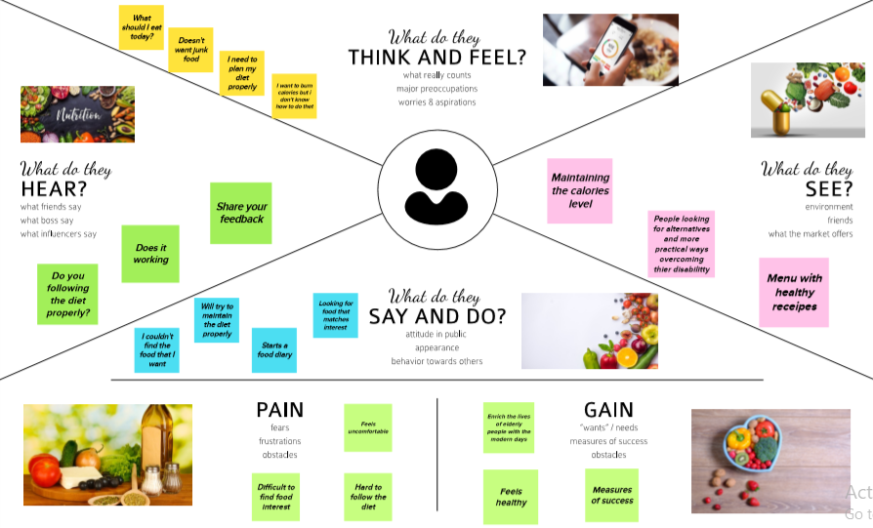

* 1. **IDEATION AND BRAIN STROMING**

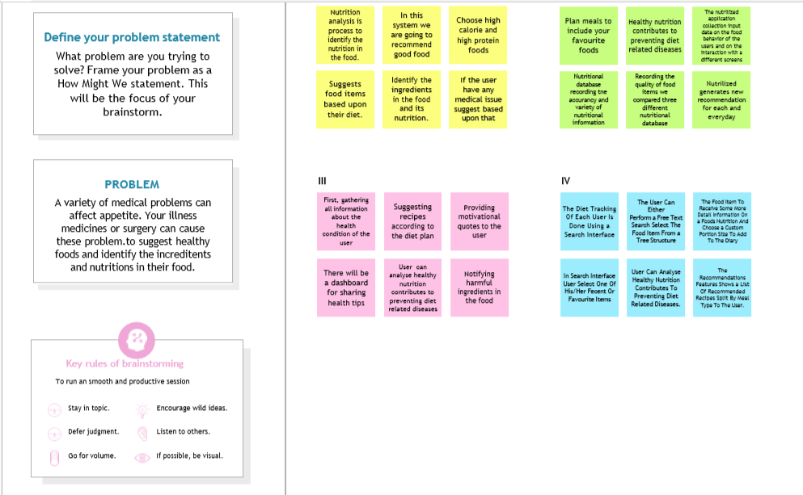

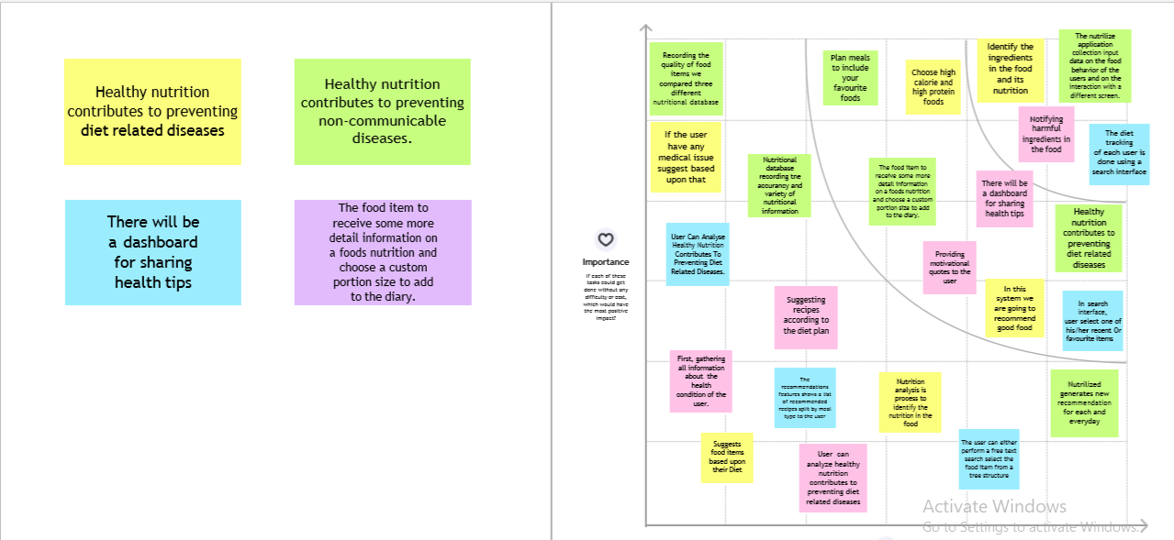

* 1. **PROPOSED SOLUTION**

|  |  |  |
| --- | --- | --- |
| **Sl. No.** | **Parameter** | **Description** |
| 1. | Problem Statement (Problem to be solved) | * Now a days peoples are not eating healthy foods with respect to their health condition. If it happens continuously means, it will lead to obesity and any other health problems. * To avoid that the system will detect and recognize the food and evaluating the nutrient values present in the food. |
| 2. | Idea / Solution description | * To store the food and details of the nutrients present in it. * Then scan the real time food and retrieve the corresponding food’s nutrient values. |
| 3. | Novelty / Uniqueness | * Clustering the peoples based on their BMI value. |
| 4. | Social Impact / Customer Satisfaction | * The application which gives awareness among the people about the obesity and various health problems. |
| 5. | Business Model (Revenue Model) | * In market, this application gives a benefit across the people by health wise and economical wise. |
| 6. | Scalability of the Solution | * The application which creates an impact among the healthy lifestyle |

* 1. **PROBLEM SOLUTION FIT**

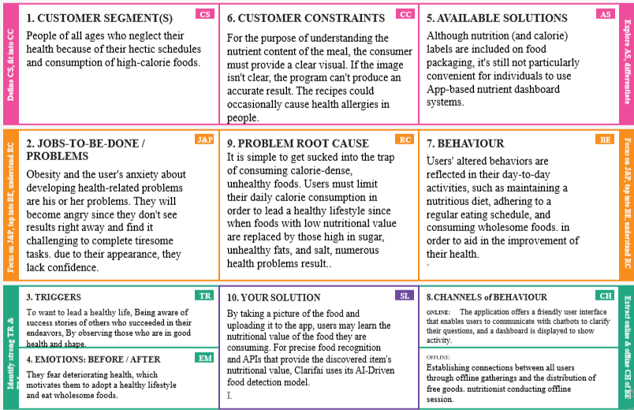

1. **REQUIREMENT ANALYSIS** 
   1. **FUNCTIONAL REQUIREMENT**

|  |  |  |
| --- | --- | --- |
| **FR No.** | **Functional Requirement (Epic)** | **Sub Requirement (Story / Sub-Task)** |
| FR-1 | User Registration | Registration through E-mail and Phone number |
| FR-2 | User Confirmation | Confirmation via Email  Confirmation via OTP |
| FR-3 | User Profile Completion | Get personal details like height, weight, etc. |
| FR-4 | Gather meal image | Upload photo  Take live photo of the meal |
| FR-5 | Display calorie information | Integrate Clarifai API to get name of the food Integrate  Nutrition API (rapid API) to collect calorie information |

* 1. **NON FUNCTIONAL REQUIREMENT**

|  |  |  |
| --- | --- | --- |
| **FR No.** | **Non-Functional Requirement** | **Description** |
| NFR-1 | **Usability** | Provide user friendly UI  Simple and intuitive design |
| NFR-2 | **Security** | Comprehensive authorization and authentication  scheme for each system actor |
| NFR-3 | **Reliability** | The system must perform without failure in  95 percent of use cases |
| NFR-4 | **Performance** | The landing page supporting several users must  provide 5 seconds or less response time |
| NFR-5 | **Availability** | Uninterrupted services must be available all time  except the time of server updating. |
| NFR-6 | **Scalability** | Provide horizontal or vertical scaling for higher  workloads |

1. **PROJECT DESIGN**

**5.1 DATA FLOW DIAGRAM**

A Data Flow Diagram (DFD) is a traditional visual representation of the information flows within a system. A neat and clear DFD can depict the right amount of the system requirement graphically. It shows how data enters and leaves the system, what changes the information, and where data is stored.

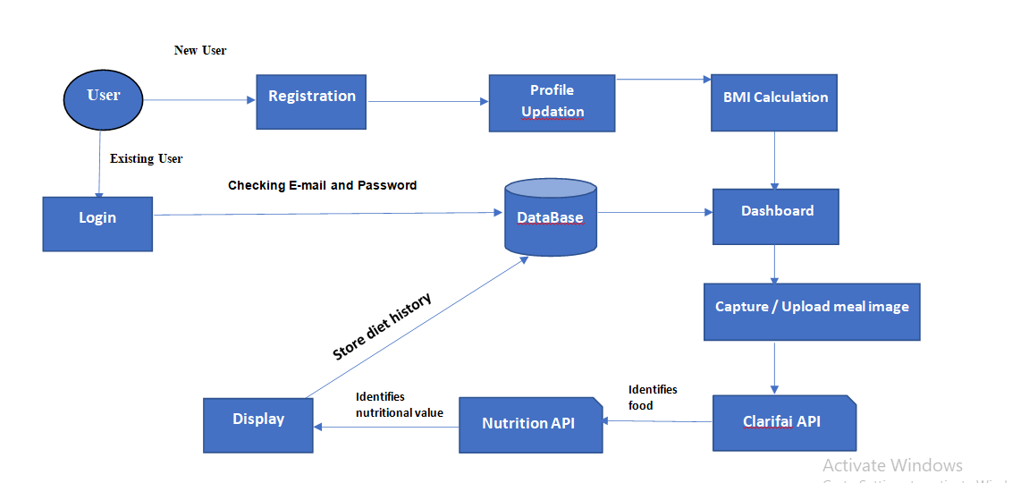

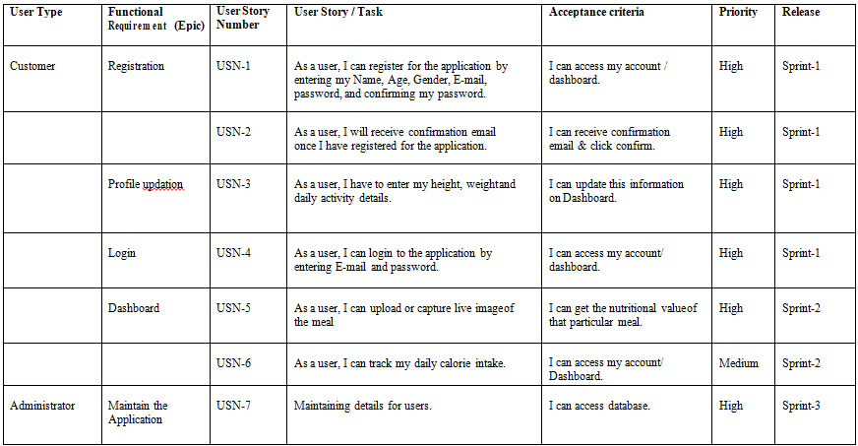

**5.2 SOLUTION AND TECHNICAL ARCHITECTURE**

Solution architecture is a complex process – with many sub-processes – that bridges the gap between business problems and technology solutions.

**SOLUTION ARCHITECTURE DIAGRAM FOR NUTRITION ASSISTANT APPLICATION**

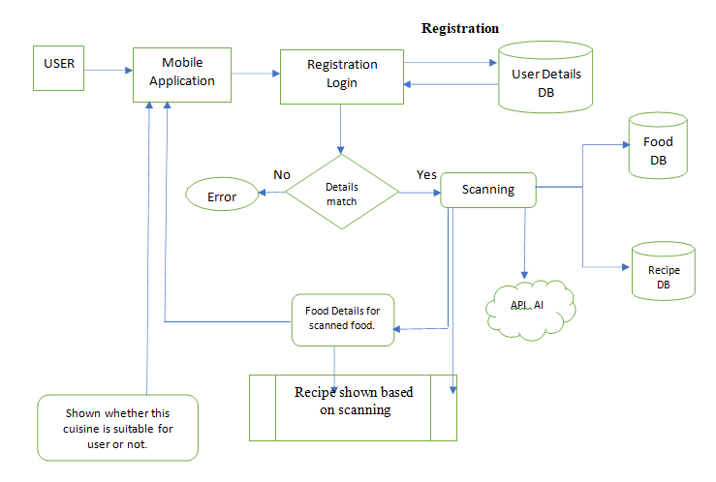

**5.3 USER STORIES**

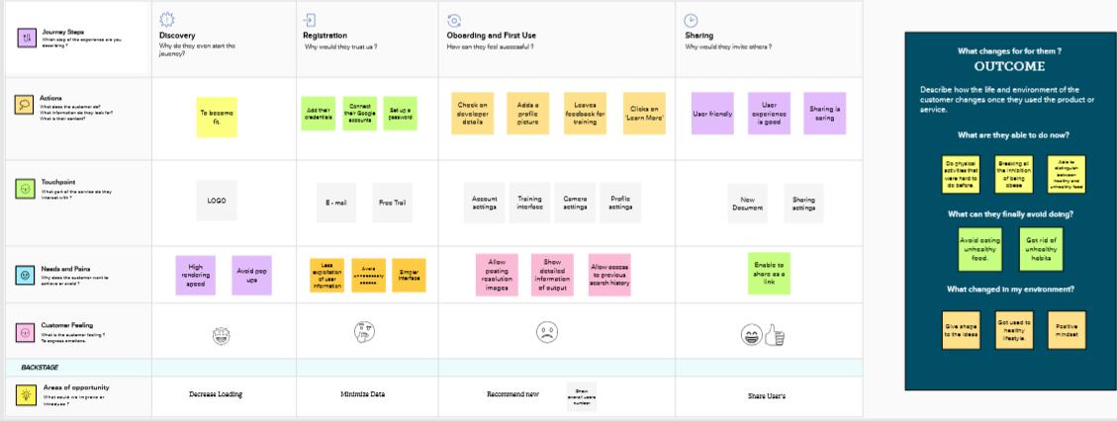

1. **PROJECT PLANNING AND SCHEDULING**
   1. **SPRINT PLANNING AND ESTIMATION**

The primary roles for nutrition in sprints are for recovery from training and competition and influencing training adaptations. Sprint success is determined largely by the power-to-mass ratio, so sprinters aim to increase muscle mass and power. However, extra mass that does not increase power may be detrimental. Energy and protein intake are important for increasing muscle mass. If energy balance is maintained, increased mass and strength are possible on a wide range of protein intakes, so energy intake is crucial. Most sprinters likely consume ample protein. The quantity of energy and protein intake necessary for optimal training adaptations depends on the individual athlete and training demands; specific recommendations for all sprinters are, at best, useless, and are potentially harmful. However, if carbohydrate and fat intake are sufficient to maintain energy levels, then increased protein intake is unlikely to be detrimental. The type and timing of protein intake and nutrients ingested concurrently must be considered when designing optimal nutritional strategies for increasing muscle mass and power. On race day, athletes should avoid foods that result in gastrointestinal discomfort, dehydration or sluggishness. Several supplements potentially influence sprint training or performance.

**6.2 SPRINT DELIVERY SCHEDULE**

Food and beverages that we eat provide the nutrients as well as the energy needed for the overall function of the body, managing diseases, improving health, and reducing the risk of diseases. Nutrition and nutrients do not just involve eating a 'good' diet; it is about providing nourishment to the body at all levels. In addition, it involves having a relationship with our own body, family, friends, community, and surroundings. The understanding of nutrition is very much essential for optimum health. Nutrition is defined as the science of food, the substances, and nutrients therein, their mechanism of action, interaction with each other, and balance with respect to disease and health. It is the process by which a living body undergo ingestion, digestion, absorption, transportation, utilization, and excretion of the food material.  The critical role of the diet is to eat foods that give us six necessary nutrients such as carbohydrates, proteins, fats, vitamins, minerals, and water. The correct variety of food with the correct amount provides all the essential nutrients insufficient for optimum health and weight management.

**7. CODING & SOLUTIONING**

**7.1 FEATURES**

**THE REGISTRATION PAGE**

When you start to diet and nutrition app development, first you should create a registration page. A registration window enables users to create their account which keeps their information safe, secure and in a complete tune such as age, gender, height, weight and eating habits, etc. Features such as smoking or alcohol consumption and food allergies should also be provided as this enables application in selecting the most appropriate meal and calorie intake for a concerned user. Social media integration can also be a trump here as it helps the app collect useful data through social channels and send personalized messages and notifications.

**DIET SUGGESTION**

The ultimate goal of the app is to help users boost their health and fitness level; thus the app should have a suggestion window for a diet plan. Make sure suggestions are provided as per the right eating habits with a spectrum of options to choose a diet.

**CONNECTIVITY WITH WEARABLE DEVICES**

The market is flooded with several wearables such as Apple Watch, Android Wear or Fitbit, etc. People are opting such devices 24x7 all to avoid unhealthy steps with could cause trouble in achieving their health and fitness goals. Develop an app which easily connects with third-party devices and enables conveniences like monitoring heart rate, distance covered by walking, cycling, swimming, running, etc. Wearables are getting so much popular; you shouldn’t use this app development tip.

**ENGAGING STATISTICS**

People are impatience today thus they swipe diet and fitness app often in between everything to track the amount of calorie burnt at a point of a day. You can provide your users an engaging statistics through presenting the data or stats in pie charts or even use attractive animations to boost motivation. [**Professional application development services**](https://www.ongraph.com/technologies/) can help you develop an app the way you wished.

**USE THIRD-PARTY APIs**

Your [**best android applications development**](https://www.ongraph.com/services/android-design-development-outsourcing-india/) strategy should include third party APIs since Google Fit and Apple HealthKit are already open and exchange the important data concerning the user’s activity. This way, your app wouldn’t need to depend on device’s embedded utilities every time for the data like steps walked or calorie burnt.

**PUSH NOTIFICATION**

Push notification is a perfect tool to remind users about anything. In a diet app, make sure push notification integrated as it sends the right message at the right time to the user about the consumption of important food along with nutritional value. With a virtual assistant, this app’s feature also gets better.

**LIVE CHAT WITH EXPERT DIETITIANS**

Some assistance from experts except in every field is a blessing to many. Additionally, it helps people understand that they are on the right track. A live chat with expert dietitians and nutritionists help people come over their health concerns and focus on proper workout regime and diet plan. Chat with experts live also has the additional advantage to you since you can charge subscription amount from both the users and secondly you will no longer need to integrate any separate program or software that supports diet plan suggestions.

**SOCIAL MEDIA SHARING**

Social channels have significant influence over people, and here we don’t need to prove it. You should integrate social media sharing option within the app which enables people to share and flaunt their fitness journey and the transformation they achieved through following the guide provided by the app. It ultimately increases your user base of the app.

**BARCODE SCANNER**

This is an exciting feature to be available in diet and nutritional mobile application. The inclusion of the barcode scanner feature helps users scan the barcode of the items. It further describes how nourishing is the item and what it contains. A user can avoid or opt the item as suggested by the diet experts to achieve perfect health conveniently.

**EVALUATION OF COST OF DEVELOPING A DIET AND NUTRITION APP**

Evaluating the actual cost of any application has always been a tricky job. Most of you must know that there is a number of factors which influence the cost of application development. For instance: each of the features takes different time for getting fully developed and functional. There are app development vendors that charge on per hour basis, and there are also companies which are flexible and also help with one-time cost estimation for a project. Plus, the cost of the app also varies significantly based on the geographical location of the app development agency.

**8. RESULT**

**8.1. PERFORMANCE MATRICS**

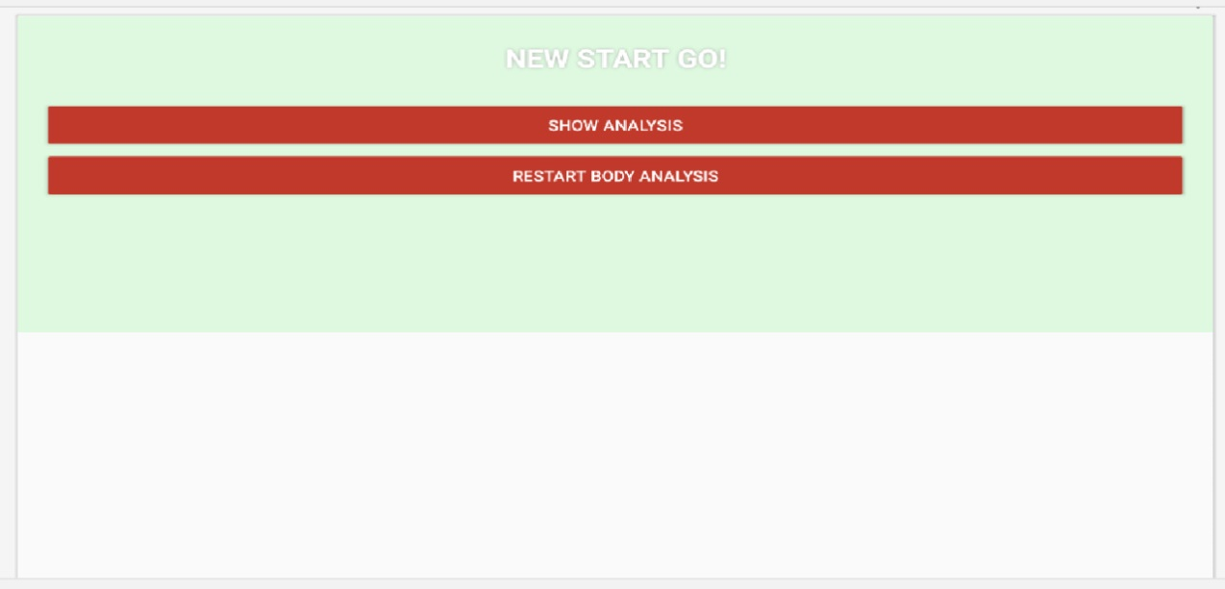

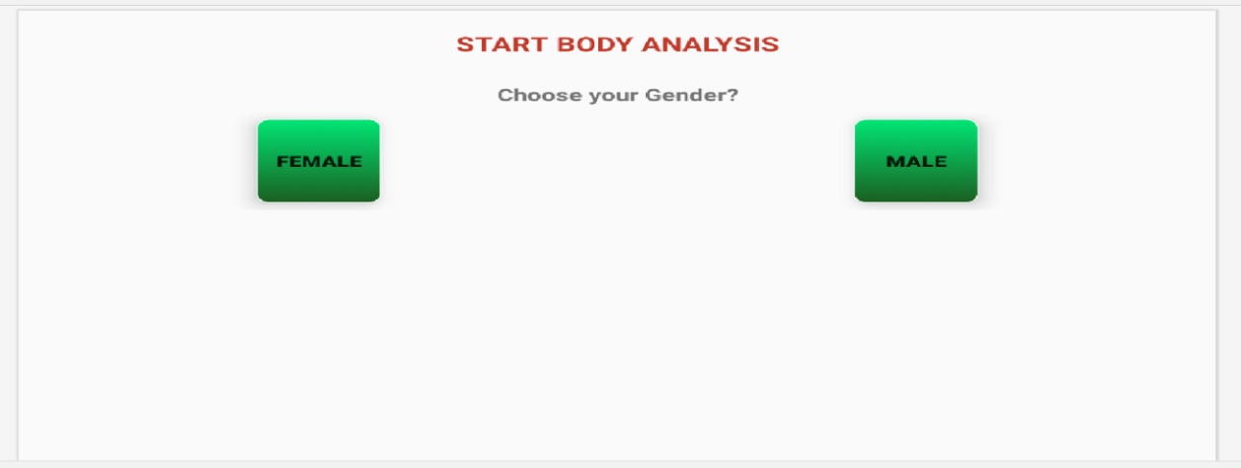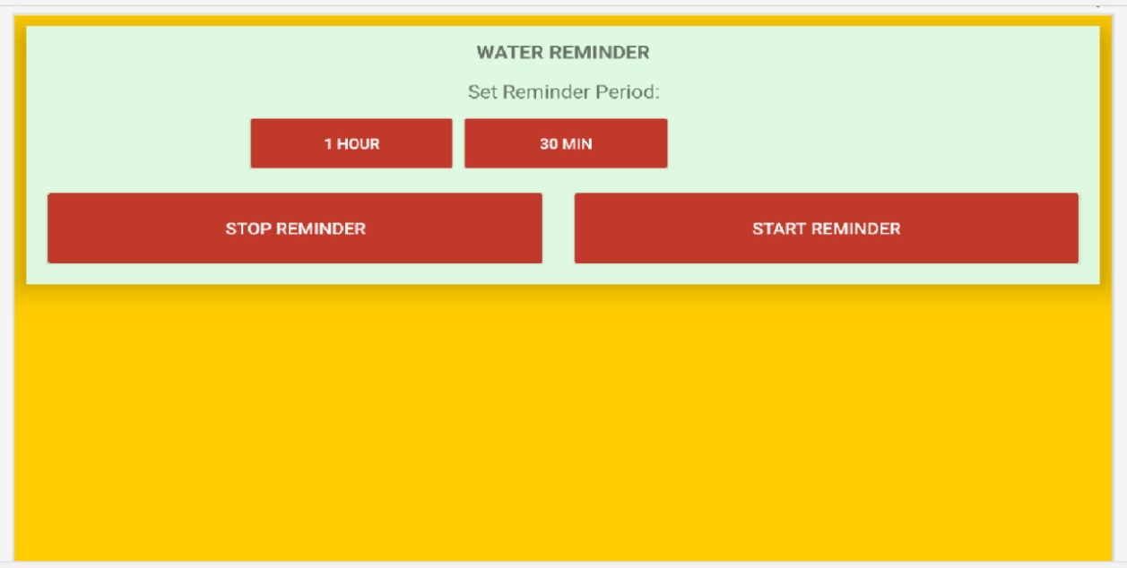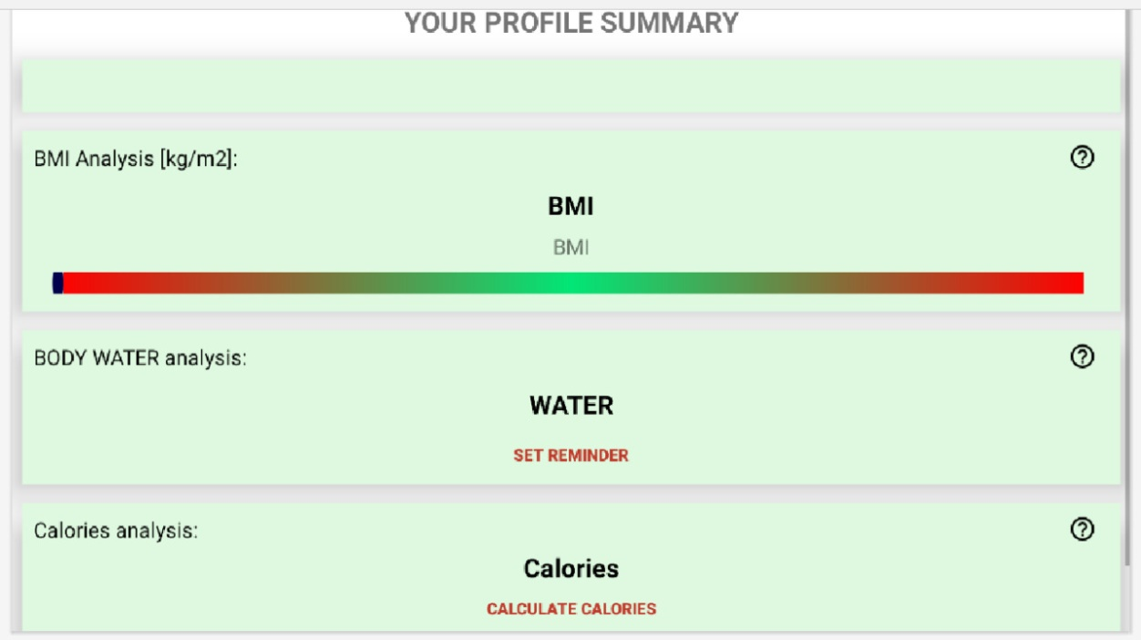

**9. ADVANTAGES & DISADVANTAGES**

**9.1. DISADVANTAGES**

* Extensive staff training required.
* Intake measured over limited time period.
* Cannot obtain difference in a specific subject’s intake over time.
* Procedure not automated.
* Subjective evalution of mixed foods.

**9.2. ADVANTAGES**

* Literacy not required.
* No subject burden.
* Unobtrusive.
* No delay in food intake start time.
* Procedure does not alter dietary habits.

**10. CONCLUSION**

The Meeting recognized that good nutrition is fundamental for children’s current and future health, as well as their development and learning. The benefits of developing healthy dietary and lifestyle patterns from an early age onwards can positively impact on people’s nutrition and health throughout their adult lives, and enhance the productivity of individuals and nations. Nutrition education is an important element in an overall strategy aimed at improving food security and preventing all forms of malnutrition. Schools (from pre-school to secondary) are ideal settings for promoting lifelong healthy eating habits and lifestyles.

Most countries in the region implement school health and nutrition programmes, including school feeding, deworming, vitamin and mineral supplementation, etc. Innovative, creative and effective school nutrition education programmes exist in some countries in the region. However, these are often small-scale and implemented as pilot projects, focus on children with special needs and prioritize the transfer of knowledge over the promotion of active learning and the creation of appropriate attitudes, life skills and behaviors. Generally, nutrition education is not systematically integrated into school curricula in the region.

**11. FUTURE SCOPE**

1. Describe progress made to-date in FANTA’s three Intermediate Results areas:

* Programs
* Policies and strategies
* Best practices and standards

2. Assess the appropriateness and effective of FANTA’s approaches/strategies and activities in achieving results to date, including operations/management, resource utilization, staffing, communications, and collaborative relations. Recommend changes, if any, needed to improve these areas in remainder of the current agreement.

3. Assess if /what changes are needed to FANTA project objectives for the second five-year agreement to ensure relevance to the current USAID policy and programming environment and to ensure it meets emerging/future needs.

**12. APPENDEX**

**12.1. SOURCE CODE**

<html>

<head>

<title>Registration form</title>

<link rel= “stylesheet” typre= “text/css”href= “res.css”>

<style>

.REGISTER {

background-color: #4CAF50;

border: none;

color: white;

padding: 15px 32px;

text-align: center;

text-decoration: none;

display: inline-block;

font-size: 16px;

margin: 4px 2px;

cursor: pointer;

}

.LOGIN HERE… {

background-color: #4CAF50;

border: none;

color: white;

padding: 15px 32px;

text-align: center;

text-decoration: none;

display: inline-block;

font-size: 16px;

margin: 4px 2px;

cursor: pointer;

}

</style>

</head>

<body>

<form>

<tr>

<td>

<input type="text" placeholder="Name" name="">

</td>

</tr>

<tr>

<td>

<input type="Phone" placeholder="Mobile No" name="">

</td> </tr>

<tr>

<td>

<input type="Email" placeholder= “Email Id” name="">

</td>

</tr>

<tr>

<td>

<input type="password" placeholder= “Password” name="">

</td>

</tr>

<tr>

<td>

<input type="Button" placeholder= “REGISTER” name="">

</td>

</tr>

<tr>

<td>

<input type="Button" placeholder= “LOGIN HERE…” name="">

</td>

</tr>

</html> <!DOCTYPE html>

<html>

<head>

<meta name="viewport" content="width=device-width, initial-scale=1">

<style>

body {font-family: Arial, Helvetica, sans-serif;} input[type=text], input[type=password] {

width: 100%;

padding: 12px 20px;

margin: 8px 0;

display: inline-block;

border: 1px solid #ccc;

box-sizing: border-box;

button {

background-color: #04AA6D;

color: white;

padding: 14px 20px;

margin: 8px 0;

border: none;

cursor: pointer;

width: 100%;

}

button:hover {

opacity: 0.8;

} .cancelbtn {

width: auto;

padding: 10px 18px;

background-color: #f44336;

} span.psw {

float: right;

padding-top: 16px;

} .close {

position: absolute;

right: 25px;

top: 0;

color: #000;

font-size: 35px; font-weight: bold;

} font-weight: bold;

} font-weight: bold;

} .cancelbtn {

width: 100%;

}

}

</style>

</head>

<body>

<button onclick="document.getElementById('id01').style.display='block'" style="width:auto;">Login</button>

<div id="id01" class="modal"> <form class="modal-content animate" action="/action_page.php" method="post">

<div class="imgcontainer">

<span onclick="document.getElementById('id01').style.display='none'" class="close" title="Close Modal">&times;</span>

<img src="img_avatar2.png" alt="Avatar" class="avatar">

</div> <div class="container">

<label for="uname"><b>Username</b></label>

<input type="text" placeholder="Enter Username" name="uname" required> <label for="psw"><b>Password</b></label>

<input type="password" placeholder="Enter Password" name="psw" required> <button type="submit">Login</button>

<label>

<input type="checkbox" checked="checked" name="remember"> Remember me

</label>

</div> <div class="container" style="background-color:#f1f1f1"> <div class="container" style="background-color:#f1f1f1"> <script>

window.onclick = function(event) {

if (event.target == modal) {

modal.style.display = "none";

}

}

</script>

</body>

</html>

from flask import Flask, current_app, send_from_directory, render_template

from flask import jsonify

from flask import request

from flask_pymongo import PyMongo

from bson import json_util

import re

import os

app = Flask(__name__, static_folder="./client/build/static",

            template_folder="./client/build")

ENV = 'prod'

app.config['MONGO_DBNAME'] = 'test'

if ENV == 'dev':

  import config

  app.debug = True

  app.config['MONGO_URI'] = config.api_key

else:

  app.debug = False

  app.config['MONGO_URI'] = os.environ.get('MONGO_URI')

mongo = PyMongo(app)

@app.route('/api/foods/all', methods=['GET'])

def get_all_foods():

  food = mongo.db.foods

  output = []

  for food in food.find():

    output.append({'ndbno': food['ndbno'], 'name': food['name'], 'weight': food['weight'],

   'measure': food['measure'], 'nutrients': food['nutrients']})

  return jsonify(output)

@app.route('/api/foods/search', methods=['GET'])

def get_queried_foods():

  food = mongo.db.foods

  fieldsets = []

  results = []

  queries = []

  nutrients_params = request.args.get('nutrients')

  mins_params = request.args.get('mins')

  maxes_params = request.args.get('maxes')

  if ',' in nutrients_params:

    nutrients = nutrients_params.split(',')

  else:

    nutrientsList = []

    nutrientsList.append(nutrients_params)

    nutrients = nutrientsList

  if ',' in mins_params:

    mins = mins_params.split(',')

  else:

    minsList = []

    minsList.append(mins_params)

    mins = minsList

  if ',' in maxes_params:

    maxes = maxes_params.split(',')

  else:

    maxesList = []

    maxesList.append(maxes_params)

    maxes = maxesList

  fieldsets.append(nutrients)

  fieldsets.append(mins)

  fieldsets.append(maxes)

  for i in range(len(fieldsets[0])):

    regex = ".*" + fieldsets[0][i] + ".*"

    query = {

      'nutrients': {

        '$elemMatch': {

          'nutrient': {"$regex": regex, "$options": "-i"},

          'gm': {

            '$gt': int(fieldsets[1][i]),

            '$lte': int(fieldsets[2][i]),

          }

        }

      }

    }

    queries.append(query)

  results = food.find({'$and' : queries})

  return json_util.dumps(results, default=json_util.default)

@app.route('/')

def index():

  return render_template("index.html")

  # ungitignored client/build, ran npm run build, deployed.

if __name__ == '__main__':

  app.run()

# Run server in watch mode:

# FLASK_APP=app.py FLASK_ENV=development flask run --port=5000

**12.2 DEMO LINK**

**https://youtu.be/eYyYDv4nmEs**